The All Orissa Girls’ Meet
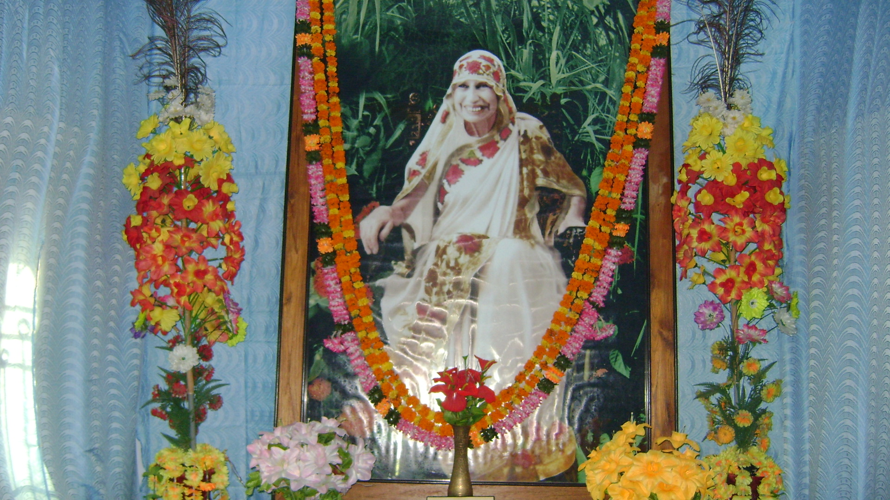
The Mother

(The 15th All Orissa Sri Aurobindo Integral Education Centre Girls’ Meet was held at ‘The Mother’s Centre for Askesis’ at Village: Raghunathpur, Dist: Balesore, Orissa, conveyed by Dr. Bijayini Mahapatra, under the auspice of Sri Aurobindo Women’s Study Circle, from 06.11.2010 to 07.11.2010. This ‘Matru Sadhana Kendra’ of village Raghunathpur seems to be an earthly paradise extending over an area of thirty five Acre land to spread Divine action and it leaves ‘the footprints of a god’. In this large gathering more than two thousand bright God’s children of delicate marvellous bud had participated, lovely is the memory of their smiling hour amid the wonder flowers of earth, destined to disclose the great and heavenly bloom. The gathering of these young eager hearts had raised some questions and the possible answers are presented here confirming the Sri Aurobindo’s vision in The Synthesis of Yoga that all truth and practice must be constantly renovated by fresh instreaming of spiritual experiences and always we must keep ourselves open to higher Words from above.)

Q 1, Who is The Mother?
A: The one whom we adore as the Divine Mother in Her physical form is at once the individual embodied Mother who mediates between the human personality of the untransformed Prakriti of twenty-four tattwas, and the Divine Nature and embodies within Her the Universal Mother, who embraces the Divine in Her own play and creations and works out the transcendent consciousness of the Supreme, enters into the world She has made, fills in it the divine all sustaining force and ananda and She is the Transcendent Mother holding all the worlds and this gross physical world and links all these worlds and planes of the Consciousness to the ever unmanifest mystery of the Supreme Being. If we make any attempt to divide these triple identities of the embodied Mother through our mind, sense and body then we suffer the division of Consciousness of the Indivisible and fragmentation of the comprehensive Knowledge. The perfection sought by us is to combine the experience of Oneness of Her highest spiritual and universal action with the possession of the fullness of Her Shakti in our individual life.

Q 2, India is the land of Spirituality, debabhumi, but why The Mother took birth in France?
A: India was spiritually strong but materially weak and was not able to bear the pressure of the Divine Mother’s birth. In Europe, the France was considered most cultured and aesthetically developed nation. Her material birth was decreed by the Supreme Lord and for which Parish was the best chosen place. In Savitri book Savitri was the princess of Madra and daughter of King Ashwapati and when She came to Satyavan’s thatched house in the forest She left the attraction of Madra’s specious hall, white carved pillars, the cool dim alcoves, tinged mosaic crystal floor, towered pavilions, wind rippled pools and garden humming with the murmur of the bees. Savitri’s materially strong background helped Her to enter highest spiritual experience in the sylvan solitude. This is the mystery behind The Mother’s birth.
Her birth was a continuation of ‘her divine unfinished work’ to ‘divinise clay’ and drive earth souls ‘to new attempt’ to conquer over Death and Fate.
One should be eager to know the golden meaning of The Mother and Sri Aurobindo’s inner life which is extended to all life or life since the beginning of the creation. The mystery of Their All Life is recorded in Savitri of which this external life history is only a small fragment. It is also observed that those who show deep interest in The Mother’s vast inner subjective experience are having spiritual future and those who recoil from it, their Nature are not prepared for any high change.

Q 3, If The Mother wanted to divinise Indian subcontinent, then why instead of taking birth in India She took birth in France. If She was born in France why she wished to bring divinity in India. She is like our Mother, like the Divine, why She was unable to know this truth before Her birth?
A: The Mother had the memory and record of Her past birth in India and other countries and She had even three emanations at one time in Europe to which our little earthly mind cannot understand. India was the place of Her soul’s choice, because it was the tapasya field of Sri Aurobindo, whom She realised as the Lord, the Godhead of Her embodied mortal life and Her second Self. Not only India, as narrated in Savitri, ‘Each soil and country it had made its home; it took all clans and peoples for her own, till the whole destiny of mankind was hers.’ (Savitri-377) Instead of limiting the physical history behind The Mother’s life, one can search the unlimited vast spiritual significance of Her Divine Birth in Savitri.
The Yoga of King Aswapati and His Divine realisation was the first part of Sri Aurobindo’s sadhana, intended to bring down the Divine Mother with highest embodied Consciousness, through whose intervention a comprehensive solution of all the problems of existence can be possible; and the second part is the Yoga of Savitri, which Sri Aurobindo continued after The Mother’s arrival which preoccupied Him in bringing down yet higher intensities of The Mother’s Supramental force in to mind, life, body, inconscient self, subliminal self and universal self. The Mother’s physical birth on earth and Her constant rebirth in to status of new divinities by intervention of higher Divine experiences are the two important phenomena behind Her earthly existence. And The Mother continued the Yoga of Savitri after Sri Aurobindo’s departure, from 1950 to 1973, which culminated in cellular transformation of the body. The Mother is still continuing Her Yoga of Savitri in subtle physical in order to bring back Satyavan to earth or bring back Sri Aurobindo in His Supramental form.

Q 4, We adore other deities in our house. Since we are reading in Sri Aurobindo Integral Education Centre so we are told to worship The Mother and Sri Aurobindo. So whom should we worship?
A: All inclusive Integral Yoga permits adoration of the exclusive Guru, Ista Devata and Avatara of the past based on our swabhava and swadharma and universalise the conception of the Deity. The all inclusive Integral Yoga permits the beginners to search the truth of existence through developmental urge developed by the Mother Nature through exclusive religion, exclusive science, exclusive schools of spiritual disciplines and shall strive to go beyond all one sided exclusiveness and arrive at the integral truth. A sadhaka of Integral Yoga cannot be satisfied ‘until he has included all other names and forms of Deity in his own conception, seen his own Ishta Devata in all others, unified all Avatars in the unity of Him who descends in the Avatara, welded the truth in all teachings into the harmony of the Eternal Wisdom.’ The Synthesis of Yoga-66
“All that is true behind polytheism as well as behind monotheism falls within the scope of his seeking (sadhaka of Integral Yoga); but he passes beyond their superficial sense to human mind to grasp their mystic truth in the Divine. He sees what is aimed at by the jarring sects and philosophies and accepts each facet of the Reality in its own place, but rejects their narrowness and errors and proceeds farther till he discovers the One Truth that binds them together.” The Synthesis of Yoga-129
“Beyond the limited human conception of God, he will pass to the one divine Eternal, but also he will meet him in the faces of the Gods, his cosmic personalities supporting the World-Play.” The Synthesis of Yoga-130
Q 5, A devotee of particular sect obeys the godhead of his choice. As we are the students of Sri Aurobindo Integral Education Centre, we are told to obey The Mother as the Divine. Then who actually is the Divine and to whom we obey and adore?
A: The Divine grows with our realisation. Initially we adore Him in a single form, that is monotheism, then we can adore and realise in His many forms, that is polytheism, then we realise Him as formless, all pervading Brahman of Adwaitin, then we realise Him as beyond form and formless, that is His Purushottam state or Supramental Consciousness. Then we can adore the One God, who is present in all godheads, deities, creatures and things.
External worship is identified as surface and crude means through which one can begin because mass of men live in their physical mind but in Yoga it will increasingly become only a physical expression of outflowing of inner adoration, consecration and sacrificial action.

Q 6, The Mother may be the emanation of Lakshmi, Kali and Durga, but why we will be obedient to The Mother and not to others?
A: “If thou hast become a slave (obedient) of thy sense instincts, then thou art fit to lead an ordinary worldly life.
If thou hast become a slave of any human form, then thou art fit to lead a spiritual life.
If thou hast become a slave to the whole of mankind, then thou art fit to become its Master.
If instead of loving woman thou can become a woman, then thou art fit to hold the Divine’s Love.”
Restated from Sri Aurobindo’s writings

Most of the human beings live in their physical and vital mind and are obedient to their promptings. Obedient to immediate authority is felt indispensable for discipline of the physical and vital mind. To become obedient to The Mother is a difficult issue because Her subtle guidance through psycho-spiritual interference can be traced only by developing the fine subliminal faculties. So a disciplined physical and vital mind either through practice of Japa (repeating the Mother’s name Maa) or through obedience to superior authority can make one fit towards The Mother’s psychic guidance. Or as Sri Aurobindo has pointed ‘if one has never been a slave to another’ then he is unfit for greatness, freedom and spiritual upliftment.
Sri Aurobindo Integral Education Centre is identified in Savitri’s language as ‘princely training’s school’ where obedience is recognised as a special privilege and nobility’s crown. (Savitri-125)
Obedience to immediate authority at each stage is indispensable for both sane ordinary life and emerging spiritual living from which the fine flower of surrender is born to enter direct contact to The Mother’s command.

Q 7, Why The Mother loves silence?
A: In Savitri it is described that in the silence and solitude the value of the human time is greatened. In silence She kindles the psychic fire and in silence She speaks to our hearts.
During Savitri’s outer wandering in search of Her own self She came across a crowded place where people were gathered together for spiritual yearning and Savitri felt the impatient longing to ‘hasten like them’ (Savitri-501) to save the God’s world. But She ‘reined back the high passion in her heart’ as She knew that those who have found their soul can only save themselves and save others and those who have found the one of the triple desire soul but not the true self can guide the world but they cannot guide themselves; so She took the firm resolution that She must first find Her soul in silence. She also observed that age long grey restraints of earth cannot be broken by the man’s slow impatient life which is leaped hurried towards a ‘sudden splendid path’ by the revelation and profound words of ‘human gods’ (Savitri-652). She was further informed that man’s ‘mind is closed between two firmaments’ (Savitri-690) of seeking truth through (1) images and words, and (2) surface and brute out sides, and is unwilling to plunge into the depth.

Q 8, Why The Mother called Sri Aurobindo Her Lord?
A: During Her first meeting with Sri Aurobindo, The Mother saw the Supreme in a human vessel and Her previous subtle physical experience on Sri Aurobindo perfectly synchronised with this outward meeting. This was Savitri’s account on Her first meeting with Satyavan:
“I have looked at him from my immortal Self,
I have seen God smile at me in Satyavan;
I have seen the Eternal in a human face.” Savitri-436
The first meeting with Satyavan offered Savitri three distinct experiences. Her illumined head, excessive physical beauty, youthfulness and brightness are further nourished with the flaming touch of Satyavan. Her inherent purity of mind, life and body restored its original purity of the soul and it is further purified and protected by the pressure and influence of the destined Lover. Her direct contact with the Divine was intensified with the new vision of the Supreme in a material form.
Savitri’s aspiration to trample all the laws of Death is echoed as
“Give me back Satyavan, my only Lord.”
Savitri-637
Q 9, How can we love The Mother?
A: The earthly base in which The Mother has kept Her feet is TRUTH. The condition in which She does Her world action is TRUTH. The condition in which She pours down Her Grace is acceptance of TRUTH and rejection of falsehood. Our love towards the Mother can be genuine and entire if we enter life with perfect beauty, perfect truth and perfect action.
In Savitri it is indicated that those who ‘wear the face of Satyavan’ are fit to receive Her entire Love, Grace and Protection. To repeat Sri Aurobindo’s spiritual experience and ascend to His spiritual status is what we understand here as ‘wearing the face of Satyavan’, to which the Divine Mother puts before us as a condition of complete oneness with Her.

Q 10, For fulfilment of our objective how can we surrender entirely before the Mother?
A: For entire surrender to be effective first we have to practice of giving of our life, work and time partly and increase our devotion towards the Mother. If we are not satisfied with this part self giving then we have to give our entire outer life to the Divine. That is the beginning of sane Ashram living. If we are not satisfied with this outer self giving then we begin to practice to give our vast inner life to the Divine. That is the life of a Sadhaka.
The four outer natures that need to be consecrated are, physical mind, tamas, vital mind, prana, emotional mind, chitta, and intellect, buddhi and the inner nature of four-fold soul forces that need consecration are the soul of self-knowledge and truth, Brahmana, the soul of courage and strength, Kshetria, the soul of mutuality and harmony, Vaisya and the soul of works and perfection, Shudra. Thus with sincere practice our surrender will be entire and we will be the slave of the God and child of The Mother.

Q 11, What is Supramental Force? Why The Mother and Sri Aurobindo wanted to bring it down?
A: Supermind is a Divine Will that knows and a Divine Knowledge that effects and creates universal harmony. It is the comprehending and containing consciousness capable of embracing, measuring, limiting and formative. It is the original self-concentration which has diffused into this world, upholds the diffusion, maintains unity in utmost diversity and stability in utmost mutability, insists on harmony in the appearance. On 29th February, 1956, the Supramental Light and Force and Consciousness rushed down upon earth in an uninterrupted flow through The Mother’s body. This experience is also hinted in Savitri and Isha Upanishad.
“The great hammer-beats of a pent-up world-heart
Burst open the narrow dams that keep us safe
Against the forces of universe.”
Savitri-83
“The face of the Truth or the Supramental world is covered with a brilliant golden lid, that do thou remove, O Fosterer, for the law of the Truth Thought, for Truth Sight.”
Isha Upannishad-15

They wanted to bring Supramental Force down because by that largest development of humanity by shortest possible path becomes possible. With the intervention of this Force, the long and tardy individual, collective and earth evolution would change into a rapid scene of Divine transformation.

Q 12, What is Divine Love?
A: It is that pure enjoyment in which the World, the Self and the God are perfectly reconciled. At present this Divine Love is least frontally active in earth’s atmosphere, least successfully redemptive and least creative because the human nature is unable to bear its purity, corrupt at once into a vital, sensuous and sensual erotic mysticism. It is the mystic flame which can rebuild the world with its tongues sacrifice. Savitri was able to compress Her evolutionary growth of thousand years into a single year by opening Herself towards this Divine Love. Sri Aurobindo proposed that in order to know the God’s love utterly one has to go through the experience of becoming a woman and serve the Master and the Lord. (SABCL/17/The Hour of God/129)

Q 13, How in our journey towards the objective we will meet victory? Explain with examples?
A: The secret of success in Integral Yoga can come when each sadhaka is able to respond adequately to the Divine call and nurture, grow and expand this Supreme Call through the central faith, which preoccupy him in the vision that see only the Divine and seek only after the Divine.
Here is one example of Supramental Experience of The Mother:
3rd November 1964: EXPERIENCE OF SUPREME’S PRESENCE IN A PERSONAL FORM.
“For the first time…, I had in a flash – it lasted just a flash – for the first time in my life, I had the PHYSICAL experience of the Supreme’s Presence in a personal form.
It was not a defined form, but it was a personal form. And it came in the wake of a series of experiences in which I saw the different attitudes of different categories of people or thinkers, according to their conviction. It came as if that form were saying to my body (it was PHYSICAL presence), as if it were saying, really with words (it was a translation; the words are always a translation—I don’t know what language the Supreme speaks (!), but it’s translated, it must be translated in everyone’s brain according to his own language) as if He were telling me, “through you” (that is through this, the body) “ I am charging…” (it was like a conquest, a battle), “I am charging to conquer the physical world.” That is how it was. And the sensation was really of an all powerful Being whose proportions were like ours, but who was everywhere at once.”
(Parallel of this experience in Savitri)
“An incense floated in the quivering air,
A mystic happiness trembled in the breast
As if the invisible Beloved had come
Assuming the sudden loveliness of a face
And close glad hands could seize his fugitive feet
And the world change with the beauty of a smile.”
Savitri-290

Q 14, Why an aimless life is like a boat without its helm?
A: Life experiences ascension of Consciousness and descent of Consciousness till the recovery of the undivided Divine life. If we put an aim based on our highest realised experiences, then only it is possible to discover the movement of Consciousness and a definite soul journey. In the aimless life the consciousness is lost through its random movement of mind without arriving any definite destination.

Q 15, How pride, ego and violence in man can be eradicated?
A: First he will reject desire, ego and attachment and will arrive at equality. After arriving at equality he will consecrate his soul and nature and experience Divine union. Out of Divine union his concentration and purity increases which gives birth to sincerity, which keeps the Nature concentrated around the soul. Then Sraddha is born which is like pouring down of Soul’s faculty of Divine Love, Light, Peace, Ananda, Force into the untransformed Nature. Thus by the Mother’s touch pride, violence and ego can be transformed.
24th May 1960: THE MOTHER’S EXPERIENCE OF DISINTEGRATION OF PHYSICAL EGO.
“For the first time, for approximately three hours, the physical ego disintegrated: the Sachchidananda spreading in a constant flood through the universe. Even the body consciousness was different. Something which was everything at once. No division. A variety of colours, vibrations, powers, and everything was within it. A universal vastness that kept going on and on… It moves and does not move. It was neither mysterious nor incomprehensible: it moves and does not move. It was neither mysterious nor incomprehensible: it was absolutely obvious; though untranslatable. Contradictory things that nevertheless all existed simultaneously.”
(Parallel of this experience in Savitri: )
Thus was she lost within to separate self;
Her mortal ego perished in God’s night.
Only a body was left, the ego’s shell
Afloat mid drift and foam of the world-sea,
A sea of dream watched by a motionless sense
In a figure of unreal reality.
Savitri-552

Q 16, Why in meditation our mind remember other things?
A: That is due to lack of mental purity. Pure mind concentrates only on the Divine.
The object of purification is to make the whole mental being a clear mirror in which the divine reality can be reflected, a clear vessel and an unobstructing channel into which the divine Presence and through which the divine Influence can be poured, a subtilised stuff which the divine nature can take possession of, new-shape and use to divine issues.
All impurity is a wrong discrimination, a departure from law of nature, dharma, and an ignorant confusion of the disordered being.

Q 17, Why we got angry in little issues?
A: That is due to impatience and suppressed desire.
Integral Yoga can begin by disciplining Desire, the great unquiet harasser and troubler of man and cause of every kind of spiritual fall and it will be transformed in to the Divine Delight of its purest form. Firstly, we have to recognize the craving-life force or desire soul overlap as multiple layers over the inmost psychic being and teach them to renounce all other desire and concentrate itself on the passion of the Divine only; secondly, after strengthening this capital point one has to further train to desire not for its own separate sake, but for the God in ourselves, God in the world and God in the Transcendence; it will not seek for any personal spiritual gain, because that is the basis of egoistic existence, but to universalize that experience and great work can be done by us for others and we can be instrumental in the glorious fulfillment of the Divine in the world through high coming manifestation and Divine Truth has to be sought and lived and enthroned for ever; lastly, the most difficult lesson is to learn to desire not in its egoistic way but in the way of the Divine. It must renounce the strong insistence of separative will and its own manner of fulfillment and its own dream of possession, its own idea of right and desirable; it must learn the lesson to fulfill the greater and larger Divine Will and consent to wait upon a less interested and ignorant guidance.

Q 18, Why during meditation I feel crying?
A: Emotion turns towards the Divine.
“At last the soul turns to eternal things,
In every shrine it cries for the clasp of God.”
Savitri-631
Q 19, What is life?
A: Life is the Force that builds, maintains and destroys forms in the world. It manifests in the form of the earth, the plant that grows upon the earth and the animals that support their existence. In man mind evolves from life. The world is then realized as a play of the Lord, with our human life as its final stage, pursued through the different phases of self-concealment and self-revelation. He must necessarily universalize and impersonalize his individualised living in order to manifest the divine All which is his life’s reality.
Q 20, In the past women were very sober and gentle though they were not educated, in the contemporary age though they know many things why they have lost these two nature?
A: The modern education activates the Prakriti part instead of pacifying it. Now the present woman has to follow the foot steps of The Mother or Savitri, who followed the footsteps of Satyavan or Sri Aurobindo. Satyavan followed the footsteps of his father, King Dyumatasena or the ancient Rishis, who lived in two solitudes, (1) outcast from the empire of outer Light and (2) lost to the comradeship of sight, sound, smell, touch and taste.
A woman can live in these two inner solitudes in her world action and retain her original nature of gentleness, soberness and humility.
A woman or man intending to hold Savitri’s consciousness can practice following sacrificial action:
“She made herself the diligent serf (or slave) of all,
Nor spared the labour of broom and jar and well,
Or close gentle tending or to heap the fire
Or altar and kitchen, no slight task allowed
To others that her woman’s strength might do.
In all her acts a strange divinity shone:
Into a simplest movement she could bring
A oneness with earth’s glowing robe of light,
A lifting up of common acts by love.”
Savitri-470
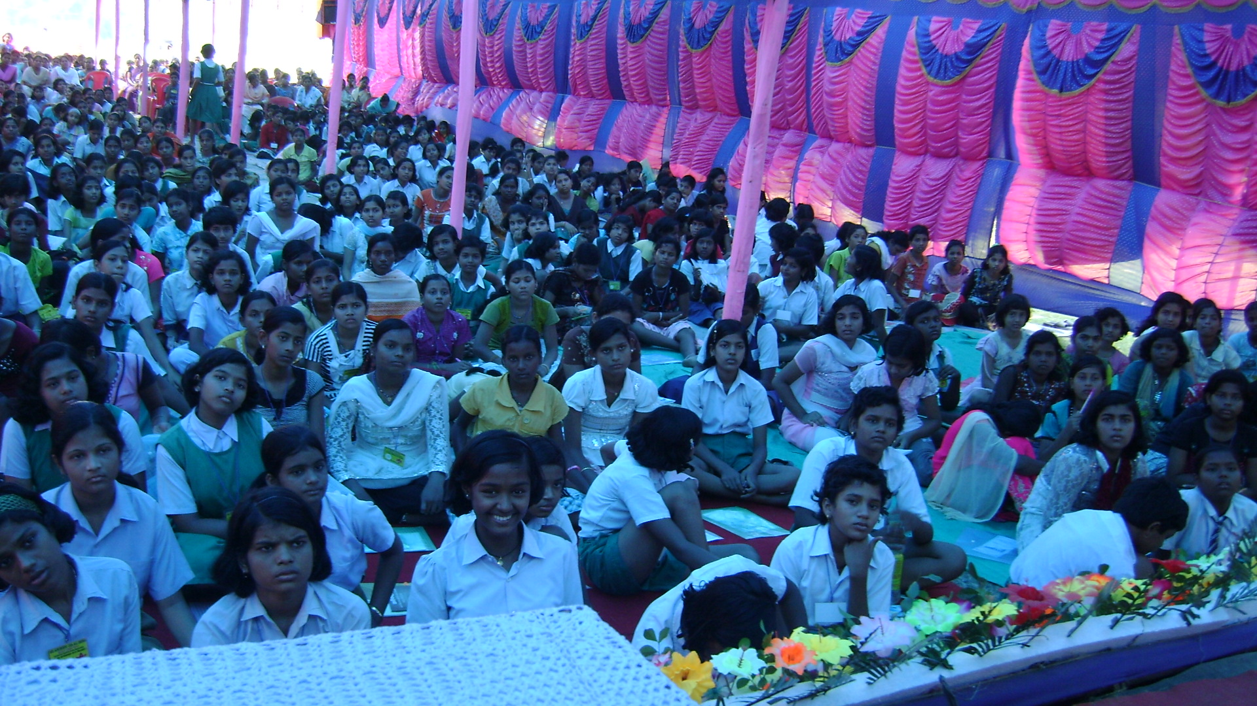
They steeped existence in their youth of soul.
Savitri-127

Q 21, How a girl can eradicate her ill health and suffering?
A: By restoring consciousness in all parts of the being.
There are two methods of eradication of suffering, one is that ascetic method of equal indifference, titiksa, the facing, enduring and conquest of all shocks of existence, to enter a distant Sachchidananda Consciousness Transcendent and aloof from the universe and other is the ancient Vedantic method where Sachchidananda Consciousness is at once Transcendent and universal and for this path is surrender and loss of ego.
The direct transformation of triple vibration of pain, pleasure and indifference in to Ananda is possible which is one of the difficult task of Integral Yoga activated in cosmic Consciousness.

Q 22, We know that the Divine is everywhere, if we cut trees then are we cutting the divine?
A: Divine is an indivisible Consciousness and cannot be divided or truncated or mutilated by our separative surface thought.
In Savitri, the Godhead has assumed a human face of Satyavan, a woodsman of the forest. Satyavan met death while cutting a tree in the forest. It was described that the soul in the tree was hurt ‘which his keen axe had cloven’. When death approached Satyavan near the hurt tree, Savitri preferred to shun this tree and leaned beneath a fortunate kingly trunk and guarded Satyavan in her bosom and Satyavan believed that by her touch death may pass away from him.

Q 23, What is my relation with the Supramental force?
A: We are related with the Supramental force in the sense that it prevents us from our real disintegration. If we will be conscious of it then it can carry us to the source of Existence or the knowledge of the One, Vidya, and knowledge of the Many, Avidya, and the link that unites the knowledge of the One and Many.
25th March 1964: THE MOTHER’S EXPERIENCE OF THE DESCENT OF TRUTH POWER.
‘Two or three nights ago, something like that occurred: in the middle of the night, early morning, there was a descent of this Force, a descent of this Truth Power; and this time it was everywhere (it’s always everywhere), but with a special concentration in the brain –not in this brain: in THE brain (The Mother’s experiences are not individual experiences, but experiences of the earth-consciousness.). And it was so strong, so strong, so strong! The head felt as if it were about to burst – so that for about two hours I simply had to keep calling for the widening of the Lord’s Peace: “Lord, Your widening, Your peace,” like that in the cells. And with the consciousness (which is always conscious, of course [gesture above]) that the descent into an unprepared brain would be enough to drive you completely mad or absolutely daze you (at the very best), or else you would burst … This experience, like the other one (Experience of 7th March), hasn’t left. …And I saw (because I wanted to see, and I saw) that the other experience was still there but it was beginning to be almost habitual, almost natural, while this one was new. It was the result of my old prayer: “Lord, take possession of this brain.” …Well, that’s what is happening—happening everywhere, all the time. So if it happens in a large enough aggregate, it gives the appearance of a miracle – but it is a miracle of the whole EARTH.’

Q 24, When we pray the Divine silently why other events visit our eye?
A: That is due to absence of mental purity. A pure mind concentrates only on the Divine. Concentration is defined as gathering back of the thought into the Self. It has three power (1) by concentration one can know any thing but this power must be utilized to know the Self, the Being , the One; (2) by concentration again the whole will can be gathered up for the knowledge of Self that is not yet grasped and (3) by concentration one can become the Self.

Q 25, How can we renounce egoism?
A: The ego is a self-limitation of consciousness by a willed ignorance and its exclusive absorption in partial movement of energies. This egoistic life finds all its values transformed and corrected when it can group round the right central conception of effective knowledge.
“When the human ego realises that its will is a tool, its wisdom ignorance and childishness, its power an infant’s groping, its virtue a pretentious impurity, and learns to trust itself to that which transcends it, that is its salvation.” The Synthesis of Yoga-59
“A greater Personality sometimes
Possesses us which yet we know is ours:
Or we adore the Master of our souls.
Then the small bodily ego thins and falls;
No more insisting on its separate self,
Losing the punctilio of its separate birth,
It leaves us one with Nature and with God.”
Savitri-47
Q 26, Who is the Divine?
A: The Vedantic formula of Integral Divine is (1) the Divine is in all things, (2) all things are within the Divine, (3) all things are made up of the stuff of the Divine. The Mother’s main method of sadhana of uniting with the Divine was to annul Her self.
29th February 1960: THE MOTHER’S EXPERIENCE OF A GOLD KRISHNA
“Fabulous experiences. A gold Krishna came. During the Darshan I was gone, perhaps everywhere: no more physical centre! Annul oneself so that the Supreme Lord may be.”
(Parallel of this experience in Savitri)
Consent to be nothing and none, dissolve Time’s work,
Cast off thy mind, step back from form and name.
Annul thyself that only God may be.
Savitri-538

Q 27, What is the relation of the Divine and the devotee?
A: Exceedingly dear devotee is he who obeys all the Law formulated by the Divine and adore Him with unceasing faith. (The Gita-12.20)
The World-Puissance on almighty Shiva’s lap,--
The Master and the Mother of all lives
Watching the worlds their twin regard had made,
And Krishna and Radha for ever entwined in bliss,
The Adorer and Adored self-lost and one.
Savitri-525
Most of the exclusive religions of the world create an unbridgeable gulf between the Divine and devotee by erecting the formula of adoration of the Personal God. In integral Yoga this gulf is bridged by defining Divinity as a state of Consciousness to which all can elevate through sacrificial work.
“The Divinity mentioned by Sri Aurobindo is NOT A PERSON, but a condition to be shared and lived by all those who prepare themselves for it.”
The Mother
“A Consciousness-Force, everywhere inherent in Existence, acting even when concealed, is the creator of the worlds, the occult secret of Nature.” The Life Divine/309
“But since this consciousness is creatrix of the world, it must be not only state of knowledge, but power of knowledge, and not only a Will to light and vision, but a Will to power and works.” The Life Divine-131

Q 28, How will we get the Divine?
A: Through Yoga. By turning our will, intellect and emotion Godward.

Q 29, Why mind is not concentrated in study? Why during study I memorise about the food and play?
A: Mind is to be purified. Mind is to be taught to think one and only thing, that is the truth of our existence.
Purity is the condition in which concentration becomes entire, rightly effective and omnipotent. Without concentration, purity can become a state of peaceful quiescence of eternal repose. The opposite of purity is identified as impurity which is defined as the confusion of the law of the soul or a mixed and mutually entangled action of the different parts of the being. And this confusion proceeds towards the absence of right concentration.

Q 30, Why anger comes often?
A: Anger is the outcome of suppressed desire.
Desire is a hunger for pleasure and satisfaction and when this limitation is transformed into the seeking after the divine delight in things then anger transforms into love.
If our sense-mind, emotional mind, thought mind could act free from the intrusions of desire and if that energy could be made to obey their right action instead of imposing its own yoke on our existence, all human problems would move harmoniously to their right solution.

Q 31, Why the divine takes away our loved objects?
A: Our right relation with the object is to love the Immutable within the mutable substance. Attachment to mutable substance is our wrong relation with the existence. So we have to make our contact strong with the loved object in order to prevent its destruction which is something other than attachment.
When the Death wanted to take Satyavan from Savitri’s lap it was not possible, because Savitri was able to follow the Death to his home in Inconscient sheath through journey in different planes of Consciousness. In Savitri it is indicated that ‘those who have lived long are made one in love’. So we have to learn the lessons how our loved object can retain immortality. These secrets can be traced through sun-lit path, golden path and the final journey of Savitri in the abysmal Night.

Q 32, How can we right use the time?
A: Time is defined as a mobile extension measured out by the succession of the past, present and future in which Mind places itself at a certain standpoint whence it looks before and after. The best utilisation of time is to protect its virginity from invasion of surrounding world and Inconscient world and enter Divine union.
Time’s virginity can be retained by building a protective fence or shield in the subtle body, permitting only the Divine vibrations to enter in. Savitri during Her inner journey and sadhana remembered one issue constantly that is the Narada’s date. This memory helped Her not to allow the time to run barren or preoccupied in transient enjoyments, rather She maintained Her effort to retain the Time’s virginity, where the marriage with the Eternity could be possible. This marriage is a constant accumulation of spiritual strength of the eternal Bride to make Her eternal tie strong with Her eternal Bridegroom. If Death can break this link then Satyavan must die, otherwise They will enter some tremendous dawn of God and never may part again in Time. Savitri was anxious to compress time so as to experience centuries in one day or shuts eternity into an hour and She was interested to build a little room for timelessness and by deep union shut God as Her cherished prisoner. A Divine force descended in Her trailing endless light to link Time’s second to eternity. The Timeless has stationed Himself in emptiness so that the soul might adventure in Time to reveal the mysteries of Eternity. Savitri claimed from Time, Her will’s eternity and God, from His slipping moments.
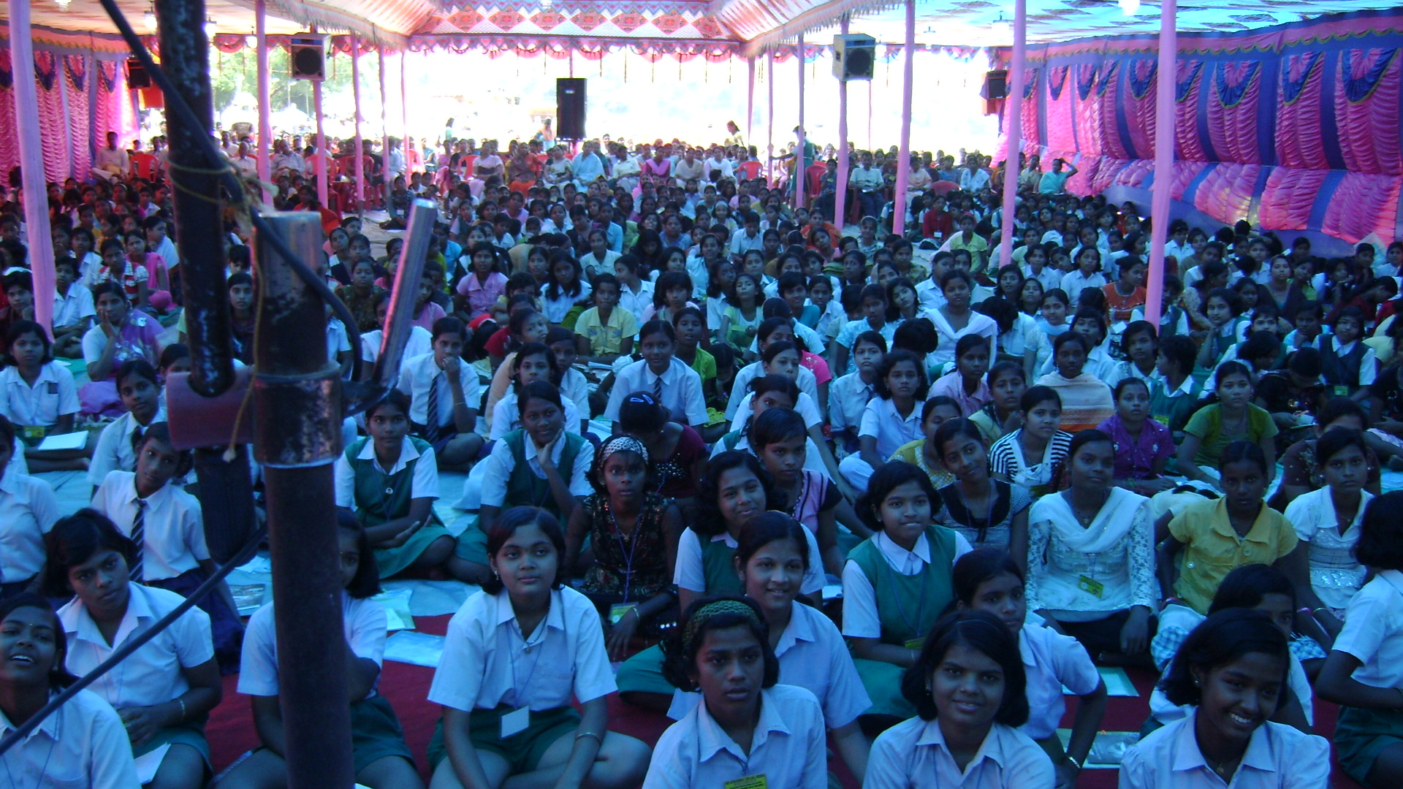
Virgin who comest perfected by joy
Savitri-424

Q 33, How can I believe that the God exists?
A: We have to intensify our faith in the Divine and meet Him in the world.
So the method with which we can meet God through Bhakti Yoga can begin is simple and straight which is always a seeking after the Divine, a longing after some kind of touch, closeness or possession. When this comes on us, the adoration becomes always primarily an inner worship; we begin to make ourselves a temple of the Divine, our thoughts and feelings a constant prayer of aspiration and a seeking, our whole life an external service and worship. It is as this change, this new soul tendency grows, that the religion of the devotee becomes a Yoga, a growing contact and union. It does not follow that out ward worship will necessarily be dispensed with, but it will increasingly become only a physical expression or outflowing of the inner devotion and adoration, the wave of the soul throwing itself out in speech and symbolic act. Therefore that there may be at all any possibility of a Yoga of devotion, we must assume first (first method of Yoga of Integral Bhakti) that the supreme Existence is not an abstraction or a state of existence, but a conscious Being; secondly, that he meets us in the universe and is in some way immanent in it as well as its source,--otherwise, we should have to go out of cosmic life to meet him; thirdly, he is capable of personal relations with us and must therefore be not incapable of personality; finally, that when we approach him by our human emotions, we receive a response in kind.

Q 34, Why the Supramental Era is not coming soon?
A: Supramental era will come when more and more individual vessels will be the pure channel of the Divine descent. The condition of Supramental era is that earth must prepare and purify herself to the extent of heaven’s purity. Those who prepare themselves to hasten the advent of Supramental era must be free from four habits that of free from attachment to food and money, free from fear of death and free from attachment to lower enjoyment.
There are intermediate ranges of Consciousness from the Matter to Supermind which must be mastered, for those who want to become a channel to bring down Supramental world. These perfections are the Truth Thought of Higher Mind, Truth Sight of Illumined Mind, Truth Vision, Truth Hearing, Truth Touch and Truth Discernment of Intuitive Mind and the source of Intuition, the Cosmic Mind or Overmind. This then is the occult link that bridges our ordinary surface living and the future Supramental life.

Q 35, How can we recognise The Mother?
A: If we can silence the mind, then we can feel with Her psychic nature and see Her with the psychic vision.
The First Contact: First one has to open one’s soul in the heart or the psychic being and dynamise four Divine Shaktis that of the Brahma Shakti of wisdom, Kshetra Shakti of Courage, Vaisya Shakti of Mutuality and Shudra Shakti of service and self-surrender.
The Second Contact: Secondly one has to open the soul in the mind above the head, the spiritual being and dynamise four Divine Shaktis that of Maheswari representing Wisdom, Mahakali, representing Power, Mahalakshmi representing Harmony and Mahasaraswti representing Perfection in work.
The Third Contact: Thirdly one has to open the soul in Supermind and dynamise four Supramental Divine Shaktis having the attributes of Truth Supreme, Power Supreme, Supreme Delight and Will Supreme.
The Fourth Contact: One has to rise to the source of the Ananda and meet the Mother’s absolute power of Chit Shakti.

Q 36, Why the God loving people suffer?
A: Suffering is the cause of insufficient flow of Consciousness force into our system. Suffering can be resolved by activation of the Consciousness Force in all the parts of our body.
“..all pain and suffering are the result of an insufficient consciousness-force in the surface being which makes it unable to deal rightly with self and Nature or unable to assimilate and to harmonise itself with the contacts of the universal Energy; they would not exist if in us there were an integral presence of the luminous Consciousness and the divine Force of an integral Being.” The Life Divine-622

Q 37, If a man follows a wrong path then how can we bring him to the right path?
A: Attachment to mutable personality creates wrong relation. So the right relation of an individual with the existence can be recovered by participation in the consciousness of the totality which includes the consciousness of the Transcendent and the Universal. A true Divine living, right and full value of life is possible when the partial movement of human mind and ego learn to submit to the All or the total movement of the Infinite instead of thinking himself infinitely important centre of existence.

Q 38, Supramental is what type of force which can build man into superman?
A: Supramental is that that type of force which can reconcile God, Self and the World and fill in the Soul and Nature equal Divine Presence. Superman is a fully transformed Nature with universalised individual Consciousness.

Q 39, Which one is more important for a woman, her beauty or her character?
A: “The physical world is the world of form, and the perfection of form is beauty.” The Mother/CWM/8/216
The most important aspect of a woman is her character of virginity of which outer and inner beauty are its attributes. Those who compromise with virginity lose higher spiritual possibility. As pointed by Sri Aurobindo that Integral Yoga becomes easy those who begin this Yoga with a ‘virgin stuff of mind and matter’. In Savitri, around twenty one distinct Nature of virginity are identified and those who open themselves towards Savitri or The Mother’s Consciousness, She protects their virginity.

Q 40, If there is Divine within us why we get angry?
A: Our soul is covered and veiled by desire soul and anger is the cause of our suppressed desire.

Q 41, I am the tomorrow’s mother. How by my sadhana the future child will be equipped with all the Divine qualities?
A: One can aspire intensely for it. That is good, safe and secured for bound soul seekers. But the motiveless spirit behind sadhana is diluted when one does sadhana to get a good job, wife, wealth and child.
Savitri became the Mother of the Satyavan’s ‘natural brother’ (Savitri-404) reared in the Divine Mother’s house who kept watch over Her children. These brother souls felt Savitri’s ‘deep childlike motherhood’ (Savitri-723) and her message of golden change was to live for love and oneness. This idea is confirmed when we find the Supreme directed Savitri, ‘Thou shalt not shrink from any brother soul.’ (Savitri-701) This is also further noticed when Savitri conquered death She identified Herself before Satyavan as ‘sister of thy soul’ and ‘mother of thy wants’. (Savitri-720)

Q 42, Can the hostile force execute Unforeseen sudden accident and death without the consent of the Supreme?
A: Accident and death are the outcome of the fixed faith and we, ourselves are the author of our doom. Hostile Forces are God’s obedient instrument missioned to fulfil the ‘long dreadful task’ (Savitri-417) in Ignorance for the acceleration of evolution in negation.
Accident and death can be avoided if we elevate our fixed destiny into spiritual destiny by opening ourselves towards the soul’s direct guidance.

Q 43, When already happened events visit our memory, what would we do?
A: We will offer it to the Divine till the truth and essence behind the event is retained in our subliminal self. When one enters deeper in sadhana the memory of the past births will also visit. They are to be put before the Spirit’s light for consecration and transformation.
“A mighty Hand then rolls mind’s firmament back,”
Savitri-154
“Her mind moved in many imaged past”
Savitri-11
“Her strong far-winging spirit travelled back,
Back to the yoke of ignorance and fate,”
Savitri-9
“Our past lives still in our unconscious selves
And by the weight of its hidden influences
Is shaped our future’s self discovery.”
Savitri-483

Q 44, How can I maintain my promise without breaking it?
A: For that mind and intellect are to be trained of clear purity. In pure mind promise can be strengthened and maintained.
In spiritual life, the mental promise is transformed into soul’s choice. When one receives the soul’s Divine call it should not be forfeited under any condition. So the soul’s Divine call is effective if there is considerable purity in mind, life and body. Savitri met three opposition against Her divine Call to lead the Divine Life with Satyavan. The first opposition was from earth Nature, in the form of her human mother, the second opposition was from her own untransformed nature and the third opposition was from the world of hostile forces and Death, the Lord of Inconscient world. Who ever will want to lead a Divine Life through divine Call will have to surmount these three oppositions. Then the soul’s choice will be effective and nothing can break the soul’s promise of attaining the Divine.

Q 45, Why jealousy visits us when we see others happiness?
A: That is the deficiency of our unfulfilled part.
Jealousy visits us when we observe superior Nature, quality and opulence in our fellow creatures. We have to increase our soul-force through activation of sraddha, followed by love for all creatures. Jealousy cannot remain when one realises that the soul-state is our highest and natural and normal state of life and action.

Q 46, Why The Mother and Sri Aurobindo descended on earth?
A:
“My soul and his indissolubly linked
In the one task for which our lives were born,
To raise the world to God in deathless Light,
To bring God down to the world on earth we came,
To change the earthly life to life divine.”
Savitri-692
The agenda of the Divine Mother, which She holds back from our sight, is to embrace and realize the Divine in Her own play and creation. Her greatness must act in every plane on earth, in heaven and in hell and She has a mighty responsibility of interfering, elevating and lifting every fixed fate and doom and cures the antithesis between heaven, earth and hell and compels Her playmate to en route the heaven’s gate through the shortcut passage of hell. Her secret and impossible task is to catch the boundless in the net of birth and cast the spirit in the physical form and lend speech and thought to the Ineffable and pushed to reveal the ever Unmanifest. Her self and all She was, She had lent to Her children to become conversant in their body’s lives so that the heaven might native grow on mortal soil. She came to help and save all the earth creatures, and to live with their grief and confront Death, Fate, Time and the riddle of man’s birth on Her way hewing towards Immortality. Her will has the capacity to alter and cancel the body’s destiny through free swift soul growth and fashion in the clay God’s perfect shape. Our present fixed fate is a child of past energies of blindness of our will in cosmic sequences and it can be our doom if the pace of the change is slow or we give the name of doom to our own choice. Her material birth was not meant to submit and suffer but to lead and deliver and Her soul’s issue was to win or lose the god like game for man thrown with Destiny’s dice. So by Her soul’s force She must dislodge Her past association, which stands as a block on the Immortal’s road and shape anew Her fate. The great World Mother in Her arose to reverse the fate’s cold dead turn, affirmed the Spirit’s tread on the surrounding, pressed back the dire senseless revolving wheels of Doom and She could bring oneness with the earth’s glowing robe of Light. She is a flaming warrior form the eternal peaks, empowered to force open the door denied and closed and established Her absolute Power in the Death’s kingdom and burst the bounds of Consciousness and Time.

Q 47, What is atma-abhimana?
A: It is a deformation of soul’s Nature of all-embracing love and one of the deficiency and limitation of mind.
Soul has to overcome four limitations of mind.
The first difficulty of the mind is identified as its inability to hold at once the unity and multiplicity of the existence.
The second difficulty is that fear, desire and sorrow are recognized as diseases of the mind, born of its sense of division and limitation.
The third difficulty of the mind is identified as its difficulty to accept and realize all this as Sachchidananda.
The fourth difficulty is to unify without losing and integralise without rejecting.

Q 48, What is Supramental Force? Why Supramental age has not yet come to earth?
A: The Supramental is at once the static self-awareness of the Infinite and Eternal and a dynamic power of self-determination inherent in that self-awareness. Supramental force can directly work in us after we enter sufficient psychicization and spiritualization of our Nature. Our untransformed nature cannot bear or receive the direct impact of a Supramental Force.
As indicated in Savitri that the earth life could have been made equal and peer of heaven and heavens joy could have stabilised on earth had earth were made pure and virgin. So when more and more people will be open towards The Mother’s virgin Consciousness, then earth will become Virgins’ Fortress and that is the arrival of Supramental age.

Q 49, What should be our prayer?
A: Our prayer should be free from blind hope, fear and desire. Our prayer can be directed towards the realisation of highest hinted spiritual experience of the Mother and Sri Aurobindo.
Prayer is the substitute of aspiration. Its utility is over with the increase of faith, will and aspiration. The highest aspiration of a soul as indicated in Savitri is to call down the Supreme Lord in its entirety.
When the one year passed swiftly and the last day arrived of the doomed husband, Savitri bowed down before a forest stone where Satyavan simply carved the great goddess of the Divine Mother and “What prayer she breathed her soul and Durga knew.” (Savitri-562) The Divine Mother who kept a watch over her child approved Savitri’s prayer of strong desire to go along with Satyavan to the forest.

Q 50, How can we know that the God exists?
A: By increasing this faith in us.
The more intimate Yoga of Bhakti resolves itself simply into these four movements, (first) the desire of the Soul when it turns towards God and the straining of its emotion towards him, (second) the pain of love and the divine return of love, (third) the delight of love possessed and the play of that delight, (fourth) and the eternal enjoyment of the divine Lover which is the heart of celestial bliss.
There are supposed by those who systematize to be three stages of seeking through the devotion of the mind, first, the constant hearing of the divine name, qualities and all that has been attached to Them, secondly, the constant thinking on Them or on the divine being or personality, thirdly, the settling and fixing of the mind on the object; and by this comes the full Divine realization.

Q 51, Why am I born in existence?
A: To reveal our concealed Divinity.
The Son of Man is supremely capable of incarnating God through human journey of sacrificial work without which he would be only an insect crawling among all other ephemeral creatures. The modern man is most discontented by the pressure of limitation and obstacle and satisfaction comes by surpassing of the limit and overcoming of the obstacle by full possession of illimitable self-consciousness, self-power and self-delight. This effort can give birth to a perfect man who combines absolute calm and passivity with free and inexhaustible activity and reconciles harmoniously three kinds of life that of the ordinary material existence, a life of mental activity and progress and unchanging spiritual beatitude and resolve their discords. A perfected human soul’s Divine work is to hasten the process of evolution of the race and his action can be steadfast and truly Divine if it proceeds on the basis of a spiritual equality, a calm, impersonal and equal self-identification with all beings. The individual exists not in himself alone but in the collectivity and the perfect utility of his perfection is, having realised in himself the divine symbol, to reproduce, multiply and universalize it in others. The individual Divine incarnation in a human body shall evolve towards universal Divine Incarnation through emergence of infinite consciousness. The many souls, minds, lives and bodies of the universal manifestation are only faces of the one Divine, only His masks and disguises. We perceive each being to be the universal Narayana presenting to us in many disguises and lose ourselves in that universality and perceive our own mind, life and body as the only valid shape and substance of manifestation of incorporeal and immaterial, while all whom we formerly conceived of as others, are now to our universal and impersonal Consciousness our self in other minds, lives and bodies.
“Infinity put on a finite soul,
All ocean lived within a wandering drop,
A time-made body housed the Illimitable.
To live this Mystery our souls came here.”
Savitri-101
Q 52, Who is responsible for knowing The Mother and Sri Aurobindo?
A: Initially our sincere effort and finally our Psychic Being. If we receive the spiritual and Supramental Influence through some external human form then as Sri Aurobindo pointed out that it is an ‘exceedingly good fortune’ for our sadhana life.

Q 53, Where from we receive actual delight?
A: “(1) Delight is existence, (2) Delight is the secret of creation, (3) Delight is the root of birth, (4) Delight is the cause of remaining in existence, (5) Delight is the end of birth and (6) that into which creation ceases.” The Life Divine108-109

Q 54, How will we know that Supramental force is working within me?
A: Supramental force is now working in us indirectly. Its direct working is possible after the Psychic and Spiritual opening. Satyavan’s preliminary spiritual experience in the forest preparing for Supramental experience through Savitri’s touch is revealed in the following lines:
“I lived in the ray but faced not the sun. (Example of spiritual life)
I looked upon the world and missed the Self, (Example of ordinary life)
And when I found the Self, I lost the world, (Example of spiritual life)
My other selves I lost and the body of God, (Example of spiritual life)
The link between the finite and the Infinite, ( Possible in Supramental)
The bridge between the appearance and the Truth, (in Supramental)
---
But now the gold link comes to me with thy feet ( Supramental link)
And His gold sun has shone on me from thy face.” (Supramental sun)
Savitri-407-408
Q 55, If The Mother is within our heart then why the asuric force enters our system?
A: Our soul is covered with untransformed desire soul, which is still connected with dark subconscient and inconscient world. These three untransformed planes are the play field of hostile forces. In Spiritual life hostile force has definite role in the soul journey.
“The giant sons of Darkness sit and plan
The drama of the earth, their tragic stage,
All who would raise the fallen world must come
Under the dangerous arches of their power;
For even the radiant children of gods
To darken their privilege is and dreadful right.
None can reach heaven who has not passed through hell.”
Savitri-226-27
Savitri, during her quest of soul came across the world of hostile force and King Aswapati while exploring planes of Consciousness met the world of falsehood, the Mother of evils and Sons of darkness. Those who can not bear the pressure of this dark kingdom or recoil from this nether hell cannot discover the soul and will suffer spiritual fall.

Q 56, Supramental force is very close to us. How can we know it and realise it?
A: By becoming aware of our psychic and spiritual existence.
“It must also be kept in mind that the supramental change is difficult, distant and ultimate stage; it must be regarded as the end of a far-off vista; it cannot be and must not be turned into a first aim, a constantly envisaged goal or an immediate objective. For it can only come into the view of possibility after much arduous self-conquest and self-exceeding, at the end of many long and trying stages of difficult self-evolution of the nature. (1) One must first acquire an inner Yogic consciousness and replace by it our ordinary view of things, natural movements, motives of life; one must revolutionise the whole present build of our being. (2) Next, we have to go still deeper, discover our veiled psychic entity and in its light and under its government psychicise our inner and outer parts, turn mind-nature, life-nature, body-nature and all our mental, vital, physical action and states and movements into a conscious instrumentation of the soul. (3) Afterwards or concurrently we have to spiritualise the being in its entirety by a descent of a divine Light, Force, Purity, Knowledge, freedom and wideness. It is necessary to break down the limits of the personal mind, life and physicality, dissolve the ego, enter into the cosmic consciousness, realise the self, acquire a spiritualised and universalised mind and heart, life-force, physical consciousness. (4) Then only the passage into supramental consciousness begins to become possible, and even then there is a difficult ascent to make each stage of which is a separate arduous achievement. ” The Synthesis of Yoga-281-282

Q 57, What steps should be taken for the upliftment of the women?
A: After the satisfaction of basic need of Food, Cloth, Shelter, Education and Health, they have to turn towards Psychic and Spiritual fulfilment.
Sri Aurobindo gave more importance to women. They have a greater role to play in Supramental transformation. They are more receptive and more plastic towards the new Consciousness. In Savitri Sri Aurobindo foresaw the dynasty of self-ruling mothers or ‘the citizens of that mother State,’ (Savitri-262) who will hasten the advent of the Supramental era. So the highest upliftment of a woman is to raise her Consciousness to The Mother’s Consciousness.
The Mother’s Consciousness is that which rests on the One and acts in the All, transcends All and denies none, sees all but lives for its transcendent task, becomes All and yet transcends the mystic whole, All ruler and is ruled by none, transcends the Light and the Darkness and yet one with the Absolute, Eternal and All-knowing it suffers mortal birth and death and in the Subconscient waits Her large unfinished task and in Inconscient She is preparing Her greatest victory.
Steps should be taken for the development of mind and intellect as pure, clear and passive reflector of the Divine which lives disinterestedly in the truth of idea for Divine action and Spiritual experience. Intellect has the capacity to trace the movement of ascending Soul and descending Shakti, through which Consciousness can be heightened, deepened and widened.

Q 58, How smile can solve the problems?
A: Smile elevates the limitation of consciousness and resolves the problems.
“And the world change with the beauty of a smile.”
Savitri-290
“Suffering was lost in her immortal smile.”
Savitri-314
“Smiling like a new born child at love and hope,”
Savitri-128

Q 59, What is ego?
A: It is the limitation of Consciousness that separates us from the Self. Ego is our helper when we live within thee gunas and domination of lower Nature. Its utility is over when we ascend to our psychic and spiritual existence.
When we live with the Divine we are united with the existence and fellow creatures and when we live with the ego and desire we are divided. The ego is dissolved when we realise that the One Divine force which is moving us and our life, the same Divine force is also moving our fellow beings, creatures and objects. Those who give themselves wholly live in the Divine’s absolute Presence. That is the end of egoistic living.

Q 60, For the upliftment and fullness of woman why health, education and virginity are necessary?
A: Good health is a strong foundation on which spiritual life can stand. Education is necessary for development of the intellect. The Gita speaks that the Divine is beyond the sense and can be caught through the doors of intellect, buddhi grahyam atindriyam. A virgin’s mind is free from narrowness and her heart is very soft, malleable and plastic towards Truth Force and hard like stone towards error, sin and falsehood. And with the help of virginity the absolute Power of the Divine Mother can be retained. Virgin Power helps to call down and hold the Divine Love which is identified as the ‘most powerful of all redeeming and creative forces’. The injunction issued in Savitri for increase of virgin power for the virgin souls is as follows:

“Or like a high-bred maiden with chaste eyes
Forbidden to walk unveiled the public ways,
She must in close secluded chambers move,
Her feeling in cloisters live or gardened paths.”
Savitri-496

Q 61, Why the Divine is perfect and within Him man is imperfect?
A: Man’s separation and fall from the original Sachchidananda Consciousness is the cause of his imperfection. The evolving Man is considered as perfection in making. The unfolding of Divine Perfection in man is part of His play.
“The Absolute, the Perfect, the Immune,
One who is in us as our secret self,
Our mask of imperfection has assumed,
He has made this tenement of flesh his own,
His image in the human measure cast
That to his divine measure we might rise;
Then in a figure of divinity
The Maker shall recast us and impose
A plan of godhead on the mortal mould
Lifting our finite minds to his Infinite,
Touching the moment with eternity.”
Savitri-67
Q 62, Why the prefix Sri is used before the Mother’s name Sri Maa?
A: Sri is one of the name of the Divine Mother. In English the prefix ‘The’ is used before The Mother to manifest Her Divinity. So in translation of Her name the nearest substitute of ‘The’ is identified as ‘Sri’ which represents the Mother’s opulence, harmony, delight, beauty and love.

Q 63, What is the significance of The Mother’s symbol?
The central circle represents the One Mother, the Supramental Mother, Aditi, who has diffused in the world as four Overmental Incarnation of Maheswari, Mahakali, Mahalakshmi and Mahasaraswati, who further diffused as twelve Psychic emanations of sincerity, humility, gratitude, perseverance, aspiration, receptivity, progress, courage, goodness, generosity, equality and peace.

Q 64, Why parents show more love and attachment to son than the daughter?
A: Due to lack of education and wrong understanding towards the existence. Now this trend has changed. Many consider daughter as more valuable resource than son. Sri Aurobindo foresaw the ‘virgin bridals of the dawn’ in Savitri, who will bring for earth ‘a happier age.’

Q 65, What is the meaning of celibacy, Brahmacharya?
A: To control the downward movement and forbidden enjoyment of mind, life and body.
Savitri, in her inward journey of discovery of soul mastered her navel-lotus centre which is identified as the seat of Brahmacharya.
“In the navel lotus’ broad imperial range
Its proud ambition and its master lusts
Were tamed into instruments of a great calm sway
To do the work of God in earthly soil.”
Savitri-530
Q 66, How a woman can be the right mother?
A: By entering right relation with the World, Self and God.
Savitri preaches motherhood for woman through ascension of Consciousness and descent of Divine Consciousness. As per Sri Aurobindo Savitri always exists on earth physically in one or multiple form, right from the beginning of the creation and She toils to elevate each soul to Her highest state of Mother Consciousness, which can burst open through following mother nature: (1) excessive of soul beauty and of soul brightness, (2) inherent purity of mind, life and body and (3) direct contact with the Divine.
So this Divine Motherhood is identified as one of the seven perfections of Integral Yoga and exclusive seeking of development of mother personality can be replaced with the development God’s total seven-fold personality of Fatherhood, Motherhood, Guruhood, Master, Lover, Friend and Playmate. And the integrality we aspire cannot be ‘real or even possible, if it were confined to individual.’ So the broadest utility of perfection is ‘extension of our liberty and of its results in others’ and Integral Yoga must constantly attempt such extension until it is completely generalised in mankind. The Synthesis of Yoga-49

Q 67, What does one mean by sadhana?
A: It is a means through whose practice one will unite with the Divine.
The practice of this Yoga proceeds through two alternative periods, initially of (1) unillumined soul season of groping, seeking and preparation through the mind’s methods of abstraction or reason’s methods of surface manipulation, in which the soul and its instruments must become fit through a lower means of approaching God indirectly or the attempt of the egoistic mind to identify itself in a wrong and imperfect way with the workings of the divine Force through movement of divagated purification, dispersed concentration and ineffective identity and arrive up to a certain point and to a certain degree of intensity only, and it is where their action ceases that finally (2) the methods of Integral Yoga takes up the growth of illumined soul season of progress through prepared and fit souls by uncovering the swift and concentrated sunlit or psychic and golden or spiritual path which approaches God directly by systematic purification of the whole being, absolute concentration on the object and compete and intimate identity of union and finds a means to reach the end of the goal. The former method of mind to pursue all Yoga insists on entire rejection of lower human nature as means of escape into higher Divine Nature whereas the latter method of the soul to pursue Integral Yoga insists on the transformation of lower human Nature by the pressure of higher Divine Nature.

Q 68, What benefit one gets out of sadhana?
A: Sadhana culminates in siddhi, perfection.
The indispensable determining factor leading to the perfection, siddhi of Integral Yoga is the intensity of soul turning inward, which is again dependent on the force of the will, concentration of the mind and aspiration of the heart.
The Integral Yogi’s distinction from other mental men is that he lives and acts in a greater vision and vaster spiritual Consciousness that he has to express or rather that presses to express itself through him and moulds his works. After realisation of the Integral Divine, the static highest Oneness and the Dynamic greatest Power, an integral Yogi returns to intermediate worlds for multiple perfection, siddhis, and again returns to earth and its multitude of problems, bears the burden of the world, enjoys Divinely its Self and Universe by renouncing the egoistic sense of desire and possession, tyaktena bhunjithah and transforms humanity.

Q 69, When I study, I do not feel reading, but if I play and do drawing then I feel good. What is the solution?
A: Solution is that mind is to be concentrated and all distraction will not find any support.
“Once our intelligence and will are well purified of all that limits them and gives them a wrong action or wrong direction, they can easily be perfected, can be made to respond to the suggestions of Truth, understand themselves and the rest of the being, see clearly and with a fine and scrupulous accuracy what they are doing and follow out the right way to do it without any hesitating or eager error or stumbling deviation.” The Synthesis of Yoga-654-55

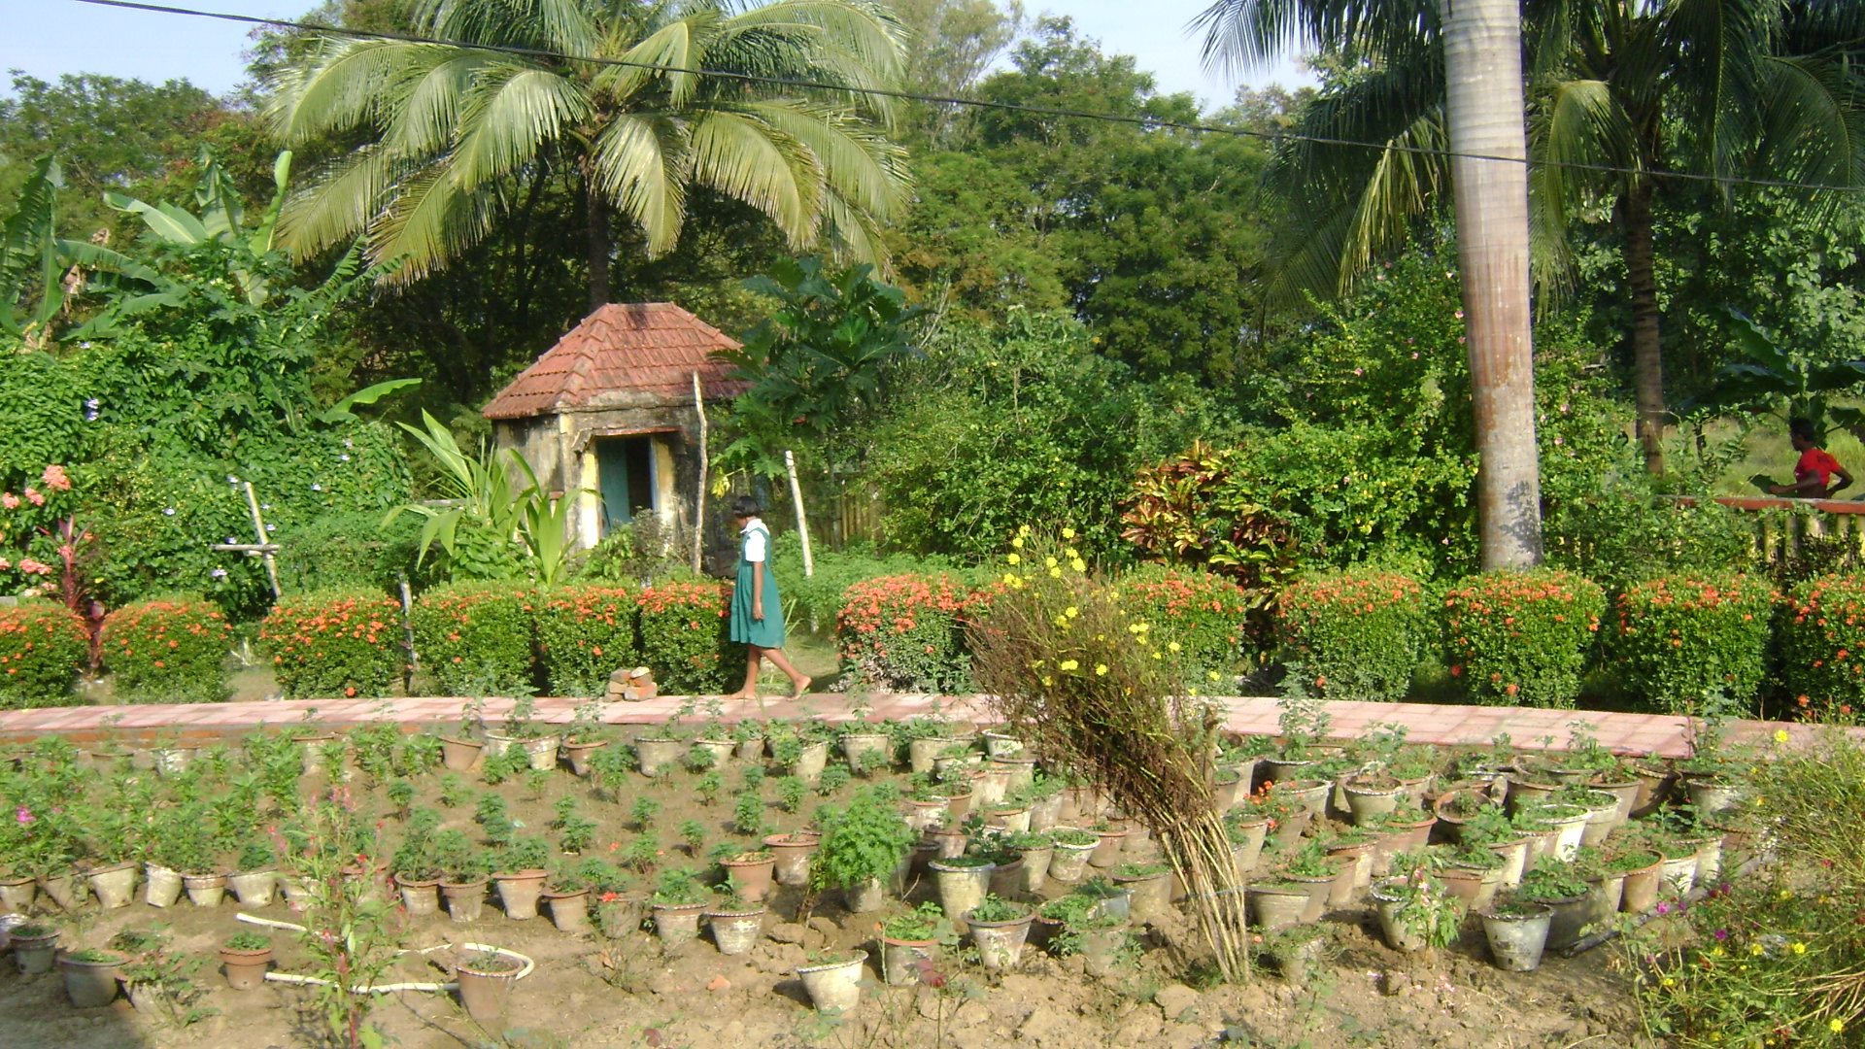
Earth must transform herself and equal Heaven
Or Heaven descend into earth’s mortal state.
Savitri-486

Q 70, What is faith?
A: Sraddha is the outcome of Purusha or Soul pouring out itself on the Prakriti. Whatever is man’s faith that he must become. Sraddha is born when one is in contact with his soul.
“A great and wide spiritual and intelligent faith, intelligent with the intelligence of that larger reason which assents to high possibilities, is the character of the sraddha needed for integral Yoga.” The Synthesis of Yoga-774

Q 71, If The Mother of distant land can accept Sri Aurobindo as the Guru, then why in this country nobody knows Sri Aurobindo?
A: Those who are destined by virtue of past birth or past evolution and have opened partly or fully their Psychic being in the heart can receive The Mother’s direct guidance and those whose spiritual being above the head are opened towards the Divine can get Sri Aurobindo’s direct guidance. Sri Aurobindo served earth like strong Sun Light, and those who have the inner eye can see it.
How The Mother recognised Sri Aurobindo at the first sight is indicated in Savitri. Savitri’s psychic being had three distinct spiritual experiences in support of Satyavan, which made Her choice firm and indispensable. At the first sight She saw and wondered at the God’s smile and vision of the Eternal in a human face and bowed down at His feet. Secondly, She was able to recollect the memories of past lives connected with Satyavan since the beginning of earth. Thirdly, She saw along with Satyavan Her future Divine manifestation on earth.

Q 72, How can we exceed the psychic being?
A: By spiritual fulfilment.
“In the integral Yoga psychical experience, especially of the kind associated with what is often called occultism and savours of the miraculous, should be altogether subordinated to spiritual truth and wait upon that for its own interpretation, illumination and sanction.” The Synthesis of Yoga-

Q 73, How development is possible of our inner soul?
A: By consecration.
Savitri in her inner journey in the highway leading to the soul met at least ten sign posts or ten traps, whose lure She must overcome in order arrive at Her psychic being. They are identified as world of titans and asuras, the world of lower nature of forbidden joy, the world of vital mind surrounding the vital self, the world of physical mind, the world of schoolman mind, the world of fixed mind, the world of outer mind, the mother of seven Sorrows, the mother of Might and the mother of Light respectively. All these domains questioned Savitri’s psychic virginity. They are all fire test to which the greatness of Her soul must overcome.

Q 74, What is true aspiration?
A: It is a flame from the psychic being. True aspiration calls down Divine Grace.
“Our souls forget to the Highest to aspire.”
Savitri-113
Q 75, Why the Divine created separate man and woman?
A: That is for the Divine’s Lila.
“He named himself for me, grew Satyavan,
For we were man and woman from the first,
The twin souls born from one undying fire.”
Savitri-614
Q 76, Why our body is not influenced by the Supramental Force?
A: The Supramental Force becomes active in an individual after his Consciousness is universalised. Consciousness becomes universalised by expansion of the subtle body. Subtle body expands by the exercise of ascent of Soul and descent of Shakti. So more our body is purified the more it will be capable to receive and hold psychic and spiritual force and finally it will culminate in the Supramental force.
“His soul, mind, heart became a single sun;”
Savitri-37
“A divinising stream possessed his veins,
His body’s cells awoke to spirit sense,
Each nerve became a burning thread of joy:
Tissue and flesh partook beatitude.
Alight, the dun unplumbed subconscient caves
Thrilled with prescience to her longed for tread
And filled with flickering crests and praying tongues.”
Savitri-334

Q 77, What is ideal of physical education for a girl?
A: To train and discipline the body so that it will be able to receive higher spiritual force.
“The body is given us as one instrument necessary to the totality of our works and it is to be used, not neglected, hurt, suppressed or abolished. If it is imperfect, recalcitrant, obstinate, so are also the other members, the vital being, heart and mind and reason. It has like them to be changed and perfected and to undergo a transformation. As we get ourselves a new life, new heart, new mind, so we have in a certain sense to build for ourselves a new body.” The Synthesis of Yoga-729-730

Q 78, What should be the ideal attitude of a woman towards physical beauty?
A: Love, Delight and Beauty are the triple manifestation of the Divine Ananda. Outer beauty of a woman should reflect her inner divine beauty.
Her body of beauty mooned the seas of bliss.
Savitri-314
In her tranquil beauty is his purest bliss.
Savitri-165

Q 79, What is the aim of life? How can we know it? What is the path and sadhana for arriving at the aim?
A: The goal of life is the emergence of the infinite Consciousness in the individual. We can know it by turning the door of our consciousness inward. The path identified for us is all-inclusive Integral Yoga which is developed from the synthesis of exclusive traditional Yoga.

Q 80, Where is the end of our suffering?
A: Suffering ends in Delight and God’s ecstatic union.
The bliss that made the world in his body lived
Savitri-682
Bliss was the pure undying truth of things
Savitri-324
Q 81, What is the utility of a camp?
A: It provides an opportunity of large Divine descent. Our mental, vital and physical deficiencies are fulfilled by The Mother’s touch and bring new hope and soul-vision for future Divine Life.
“A camp of God is pitched in human time.”
Savitri-531
On 29th February, 1956, during a collective meditation in the playground of Sri Aurobindo Ashram, the Supramental Force descended through the pure channel of The Mother’s body. All collective gathering is an opportunity for the pure souls as instrumental channel for the descent of higher spiritual force and also it can be prepared as fit ground for highest descent of Supramental force.

Q82, Why there is no courage to speak truth?
A: Because we do not reject falsehood.
“The truth is always the One at work on itself, at play with itself, infinite in unity, infinite in multiplicity.” The Synthesis of Yoga- 367
“Lying is always the sign of lack of courage. A refusal to face the situation as it is.”
The Mother
Q 83, What is soul?
A: The soul is the Immutable Personality within us who has consented to wear this garb of mutable personality.
Initially the Gita has identified the double soul in man (verse-6-5, 6); one that of the surface desire soul carrying in its nature the apparent nature of lower instincts, emotions, the mental seeking for power, knowledge and happiness and the other behind it that of the true soul, the psychic being, a pure power of light, love, joy and beauty. The desire soul’s wrong approach and reception towards life deforms the pure joy into pleasure, pain and indifference. True soul is the imperishable, evolves in us from birth to birth and untouched by death, decay and corruption. It is actually the psychic sheath that grows from birth to birth by entering the essence of all experience of psychic self in the Ignorance. A mastery of senses, the ability to do without all that they hanker after is the initial condition of the true soul life.

Q 84, Why are we created in this earth? What is the aim of our life?
A: To fulfil God in life is man’s manhood. Aim of our life is to unveil in the perfected body and mind the transcendent activities of the Spirit.
“Our life’s repose is in the Infinite;
It cannot end, its end is Life supreme.”
Savitri-197
Q 85, Why man remembers the Divine during the danger?
A: There are four kinds of devotees of the Divine that of arta, artharthi, jinjnasu and jnani. The arta or the tamasic devotee remembers the divine only during the period of crisis. Devotion begins with that but constant remembrance must be our aim.

Q 86, What man wants in the world why he does not get it?
A:
“If human will could be made one with God’s,
If human thought could echo the thoughts of God,
Man might be all-knowing and omnipotent;
But now he walks in Nature’s doubtful ray.”
Savitri-457

Q 87, Why the sorrow breaks down a man?
A: Attachment to mutable personality is the cause of sorrow.
Satyavan’s death in the forest is described in the following lines:
“Her husband’s corpse on her forsaken breast.
In her vast silent spirit motionless
She measured not her loss with helpless thoughts,
Nor rent with tears the marble seals of pain…
In a great stillness without stir or voice,
As if her mind had died with Satyavan.”
Savitri-573
Q 88, What man leaves behind after death?
A: The soul with its multiple subtle bodies leaves behind the gross body after death.
With the death of Satyavan in the forest, Satyavan’s psychic being entered different domains of the inconscient world along with Savitri and the Death, who is considered as guardian or the godhead of Inconscient world. Savitri entered these dark worlds, layer after layer armed with fragments of ‘Truth Supreme’ and ‘Light Supreme’ and this Truth-Light had to grow fully with intervention of higher spiritual experiences. The innermost domain of Inconscient self is the most dark, stubborn, rigid and there is strong unwillingness towards any change. This is the home of Death to which every living being returns. The death of Death in his own home is the Divine Mother’s final victory of Truth-Light over dark forces. The transition between Satyavan’s death and return to earth life is the period of cellular transformation of humanity in which Satyavan’s subtle physical experienced the transformation of whole world of the Inconscient sheath.

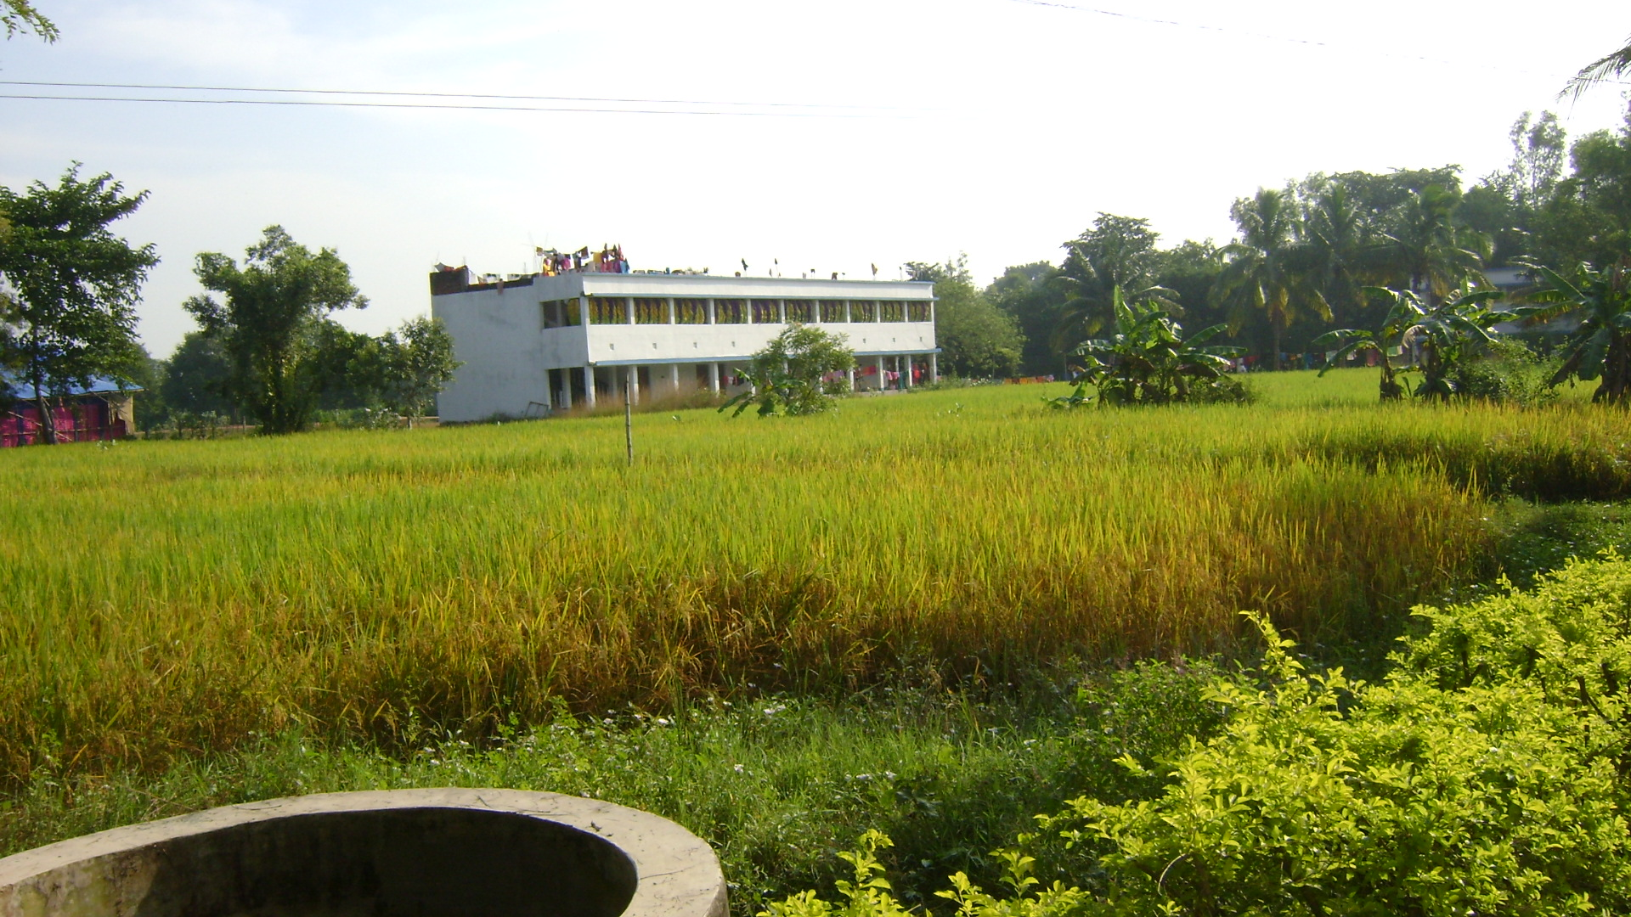
Sri Aurobindo Integral Education Centre at Raghunathpur

Q 89, How mind, life and body can be transformed?
A: After the experience of the Divine union if the gained Divine consciousness is inverted earthward then mind, life and body experiences transformation.
The starting point of the Mother’s Yoga is identified as to detect first what is false or obscure in us and persistently reject it. This will permit the unfailing aspiration to rise like a flame from our psychic being and burn upward towards the heaven. Then submission of our Prakriti near the Purusha which is identified as surrender permits the Prakriti to merge with Purusha and the Divine Union is realized. This divine union causes to Prakriti to concentrate more and more around Purusha which is identified as sincerity. And through sincerity our union with the Divine is prolonged and Sraddha becomes active in which the Purusha pours down into Prakriti its attributes in the form of Truth, Love, Delight, Will, Wisdom and the Divine Shakti is realized. Then this action of divine Shakti becomes frequent and constant and one realizes transformation of mind, life and body.

Q 90, Why man meets death?
A: “Disintegration of substance and renewal of substance, maintenance of form and change of form are the constant process of life; death is merely a rapid disintegration subservient to life’s necessity of change and variation of formal experience.” The Life Divine:188-89
Savitri gathered and accumulated Her spiritual force silently till the hour when Satyavan must die. Death can take away Satyavan only if he can break the strong subtle spiritual link between Savitri and Satyavan. This is the secret of immortality which Savitri teaches us. Each moment of our life is offered to us to accumulate the spiritual force within us to meet and confront the critical hour of death.

Q 91, How mind can be controlled?
A: Mind can be controlled by concentration, contemplation and meditation.
It can also be controlled by Jnana Yoga, by chintana, manana and nidhidhyasa.
Through Bhakti Yoga, by manana, darshana and Samadhi.

Q 92, Why man takes human birth repeatedly?
A: Rebirth is an opportunity of spiritual evolution and through it the mind, life and body repeat the lesson of manifesting their involved Divinity till the recovery of their complete and undivided Divine Life.

Q 93, What we have to do to fulfil our aim?
A: Effort.
We can move mind’s faculty of exclusive concentration forward to realise our objective perfection and by its reverse movement we realise subjective perfection and discovery of the soul.
‘The concentration of an enlightened thought, will and heart turned in unison towards one vast goal of our knowledge, one luminous and infinite source of our action, one imperishable object of our emotion is the starting point of the Yoga.’ The Synthesis of Yoga/ 80
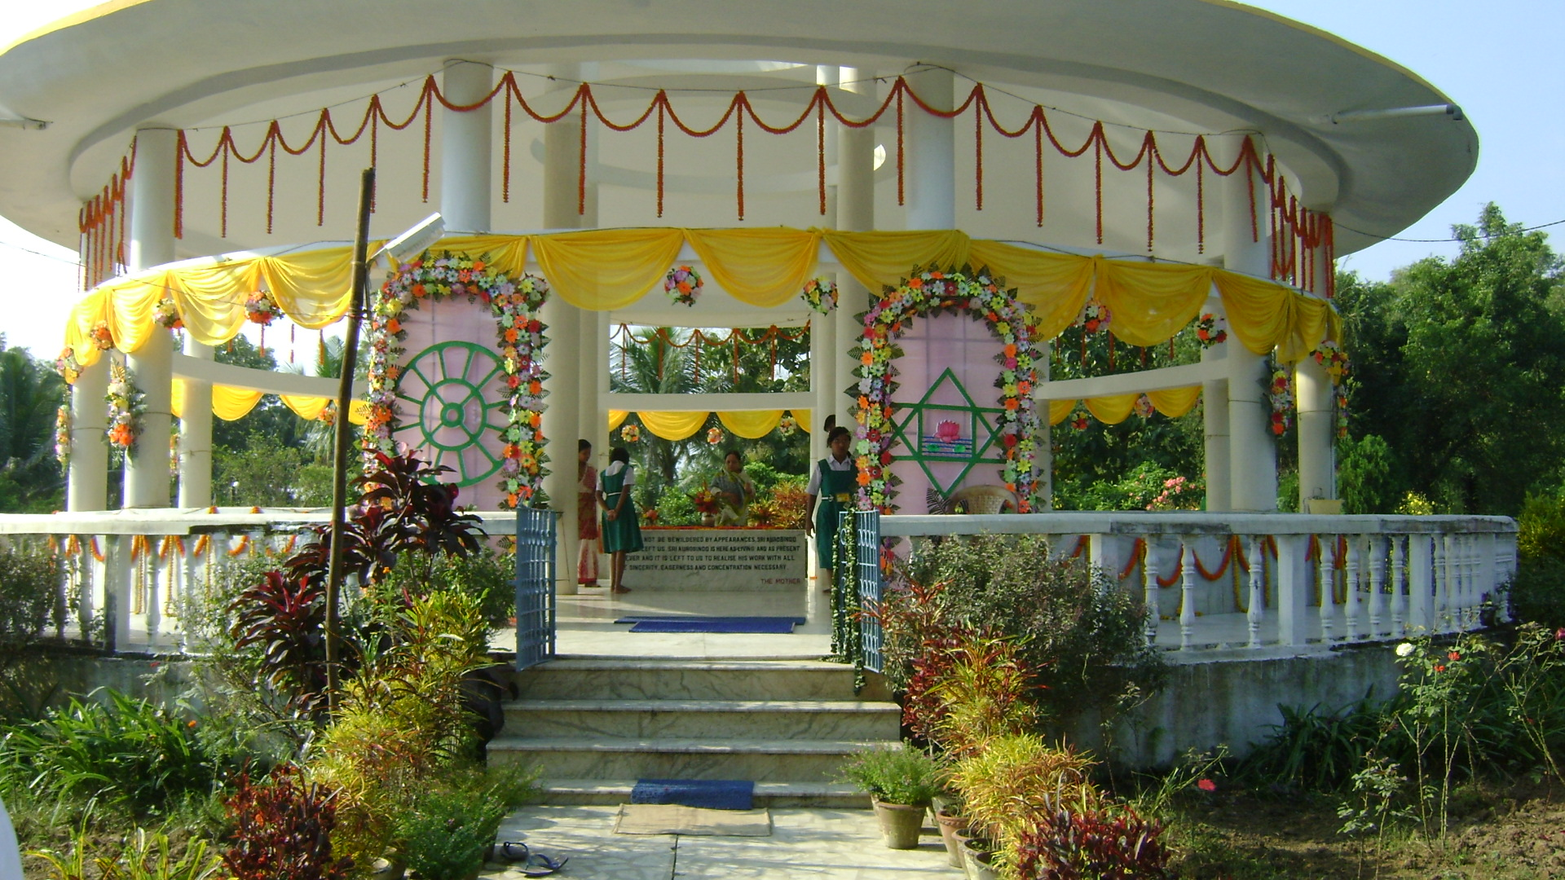
Sri Aurobindo’s Sacred Relics at Raghunathpur

Q 94, What is the mantra of Karmayoga?
“At each step we can say in the language of the Sanskrit verse, “Even as I am appointed by Thee seated in my heart, so, O Lord, I act.” Yatha prayukto’smi (niyukto’smi) tatha karomi. (Pandvagita)” The Synthesis of Yoga- 252
“Even the smallest and meanest work became
A sweet or glad and glorious sacrament,
An offering to the self of the great world
Or a service to the One in each and all.”
Savitri-532
Q 95, Why we conduct study circle?
A: The study circle is a small collective gathering to resolve the problem of mutuality of a Sangha, through intervention of the Divine, the force of unity and Dharma, the force of harmony; it is like a temple where one can receive Divine’s touch and harmonize his problems; a true study circle can transform into Divine Centre of the world, a powerful channel to receive and transmit the Divine Grace, where the whole of humanity will be benefited as a Sangha. The study circle initially serves as means of initiating our soul and finally serves as means of finding the Divine.

Q 96, We have read in the book that there is nothing bad in the world, there is nothing bad and good. Everything is right in its own place. If we turn bad then are we not the Mother’s children?
A: “That which is an apparent discord to the mind because it considers each thing separately in itself, is an element of the general ever-present and ever-developing harmony to the Supermind because it views all things in a multiple unity. Besides, the mind sees only a given time and space and views many possibilities pell-mell as all more or less realisable in that time and space; the divine Supermind sees the whole extension of time and Space and can embrace all the mind’s possibilities and very many more not visible to the mind, but without any error, groping or confusion; for it perceives each potentiality in its proper force, essential necessity, right relation to the others and the time, place and circumstance both of its gradual and its ultimate realisation. To see things steadily and see them whole is not possible to the mind; but it is very nature of the transcendent Supermind.” The Life Divine-144-45
The Mother’s grace works only in the condition of the Truth and the Right though all are parcels and portions of Her Divine conscious Force, Her children and portions of the One.
So those who wish to relate rightly and lovingly with The Mother, for them obedience to following ten norms are imperative as indicated in The Mother book:
A: ‘But the supreme Grace will act only in the conditions of the Light and the Truth; it will not act in conditions laid upon it by the Falsehood and Ignorance. For if it were to yield to the demands of the Falsehood, it would defeat its own purpose.’ 1
B: ‘If part of the being surrenders, but another part reserves itself, follows its own way or makes its own conditions, then each time that that happens, you are yourself pushing the divine Grace away from you.’ 3
C: ‘If behind your devotion and surrender you make a cover for your desires, egoistic demands and vital insistences, if you put these things in place of the true aspiration or mix them with it and try to impose them on the Divine Shakti, then it is idle to invoke the divine Grace to transform you.’ 3
D: ‘If you open yourself on one side or in one part to the Truth and on another side are constantly opening the gates to hostile forces, it is vain to expect that the divine Grace will abide with you.’ 4
E: ‘If each time the Power intervenes and brings in the Truth, you turn your back on it and call in again the falsehood that has been expelled, it is not the divine Grace that you must blame for failing you, but the falsity of your own will and the imperfection of your surrender.’ 4
F: ‘If you call for the Truth and yet something in you chooses what is false, ignorant and undivine or even simply is unwilling to reject it altogether, then always you will be open to attack and the Grace will recede from you.’ 4-5
G: Detect first what is false or obscure in you and persistently reject it, then alone can you rightly call for the divine Power to transform you.’ 4-5
H: ‘Do not imagine that the truth and falsehood, light and darkness, surrender and selfishness can be allowed to dwell together in the house consecrated to the Divine. The transformation must be integral, and integral therefore the rejection of all that withstands it.’ 5
I: ‘Reject the false notion that the divine Power will do and is bound to do everything for you at your demand and even though you do not satisfy the conditions laid down by the Supreme.’ 5
J: ‘Make your surrender true and complete, then only will all else be done for you.’ 5
Q 97, How can we know The Mother?
Ans: Those who have learned the lesson of ascending and descending movement of Consciousness, know The Mother partly and by intensifying this movement they can know Her entirely. For movement of consciousness we can take the assistance of the book The Life Divine, and concentrate more on its last six chapters.

Recapitulation:
Now, in this hour of God, mind must be fixed in the highest hinted spiritual experiences of the past and present, vital must be preoccupied in uncovering the pure undying truth and celestial joy of sense and body must quiver with Eternity’s touch. This All Orissa Girls’ Meet gave the opportunity to girl students from the age of twelve to nineteen to experience large Divine descent through different activities and educational programme. Earth life needs such Divine Presence in its ever growing intensities in coming days.
This paper proposes that the young mind’s problem of accepting The Mother can be resolved if present trend of entering The Mother’s external life be replaced by entering Her vast inner life of All Life extending from beginning of the creation till the promise of Savitri that ‘the mighty Mother shall (again) take birth in Time’. This paper further proposes that their approach of the Divine from the beginning should be all-inclusive instead of exclusive. The all-inclusive embodied Mother who dwells in everybody’s heart is also universal Mother pervading every thing and every being and all deities and all godheads and She is also the Transcendent Mother, the source and becoming of all this existence. This paper also proposes that the young mind must be aware of tapasya, consecration and movement of Consciousness as means of entering contact with the inexhaustible height, depth and wideness of The Mother’s Consciousness. Their present interest to know more about Sraddha, Surrender, Soul, Supramental, Virginity, silencing the Mind, Aim of Life, Education, Divine Love, Delight, require right and complete attention.

OM TAT SAT

Edited by S.A. Maa Krishna,
Sri Matriniketan Ashram,
Managed by The Mother’s International Centre Trust,
Vill: Ramachandrapur, PO: Kukudakhandi-761100, Via: Brahmapur,
Dist: Ganjam, State: Orissa, India
www.srimatriniketanashram.org

